**ASSIGNMENT 1**

**1.Interchange first and last elements in a list.**

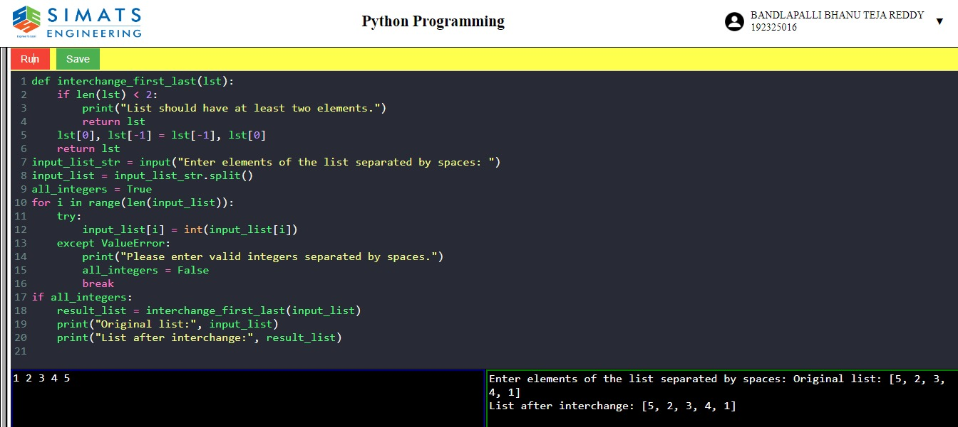

**2.swap the two elements in list.**

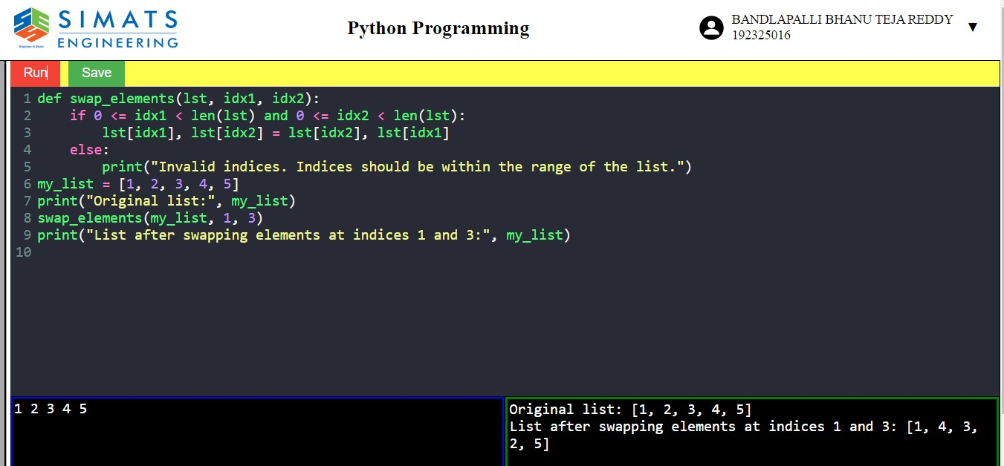

**3.reverse the words in a string.**

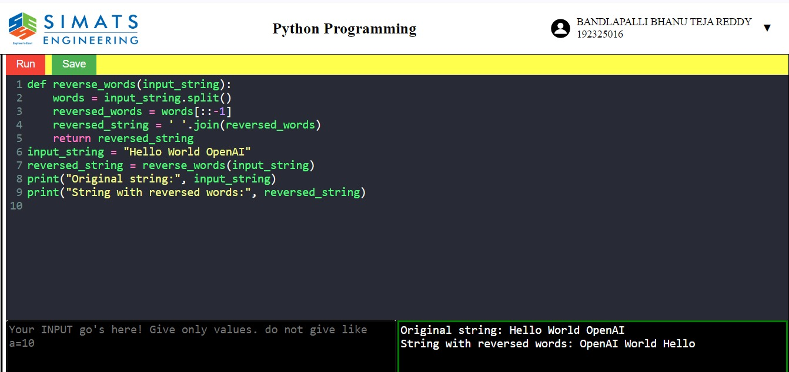

**4.length of the string.**

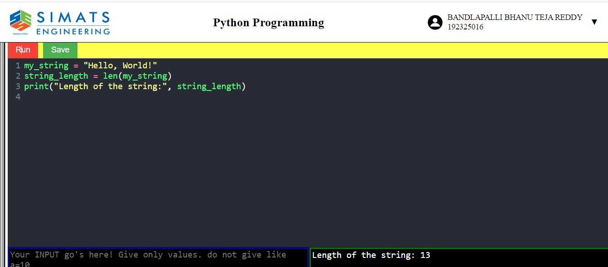

**5.find minimum and maximum elements in a list.**

